ASSIGNMENT 4

Question 1

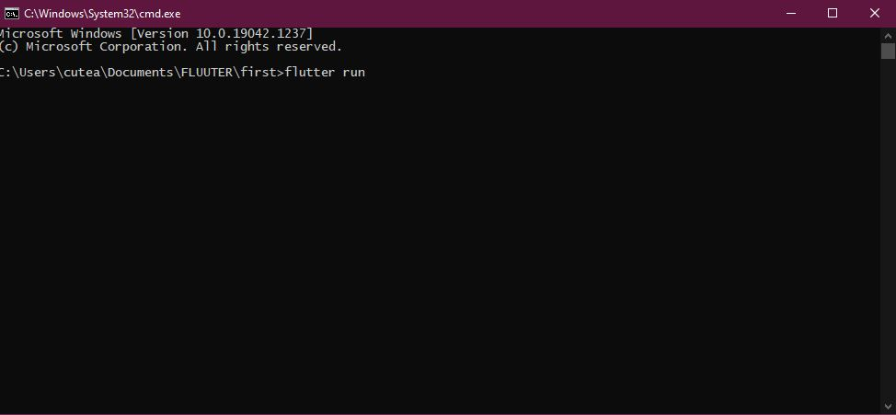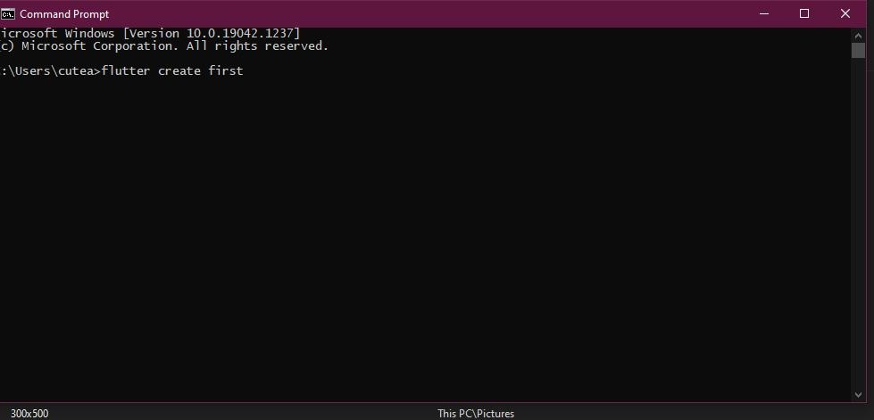

Question 2

void main() {

void number( int num){

for(var i=1; i<=15; i++){

print("${num} \* ${i} = ${num\*i}");

}}

number(4);

}

Question 3

void main() {

void myfunc(int num1){

List mylst = [2,4,6,8,9];

for(var i=0;i<mylst.length;i++){

print(mylst[i] / num1);

}

}

myfunc(3);

}

Question 5

class abc{

abc(){

print("hello");

}

}

void main() {

var obj=new abc();

print(obj);

Question 6

class abc{

void p(){

var name = "hasan";

print(name);

}

}

void main() {

var name = new abc();

name.p();

}

Question 7

void main() {

Detail c1 = new Detail.namedConst('hasan',65,"iiii");

Detail c2 = new Detail();

}

class Detail {

Detail() {

print("Non");

}

Detail.namedConst(String name,int age, String education) {

print("The name is : ${name} Age is : ${age} Educations: ${education}");

}

}

Question 8

void main() {

Dog mycat = new Dog();

mycat.run();

mycat.breathe();

}

class Animal {

late double weight;

void breathe(){

print('i am breathing fresh air');

}

}

class Dog extends Animal{

late int legs;

void run(){

print('i am breathing on my legs');

}

}